Project Name: Hotel Management System
Course: Software Engineering
GROUP MEMBERS
Aron Kiplangat – E020-01-0934/2023
Bruce Boge – E020-01-0941/2023
Hezzron Nyakeruma – E020-01-0943/2023
Pharrel Muga – E020-01-2145/2023
Alex Githinji – E020-01-0883/2023
Blair Nduta -E020-01-2120/2023
Purity Mutemi -E020-01-2356/2022
Donald kosgei -E020-01-2079/2023
Kilavi Musyoki -E020-01-0896/2023
Beverlyne Tanui -E020-01-0947/2023

The Hotel Management System is a comprehensive software solution designed to automate the core processes of the hospitality industry. Its primary purpose is to bridge the gap between guest requirements and hotel resource management by providing a centralized platform for room reservations, guest check-ins, and financial tracking. The system replaces manual paper-based logs with a digital ecosystem that ensures real-time data accuracy and improves overall service delivery

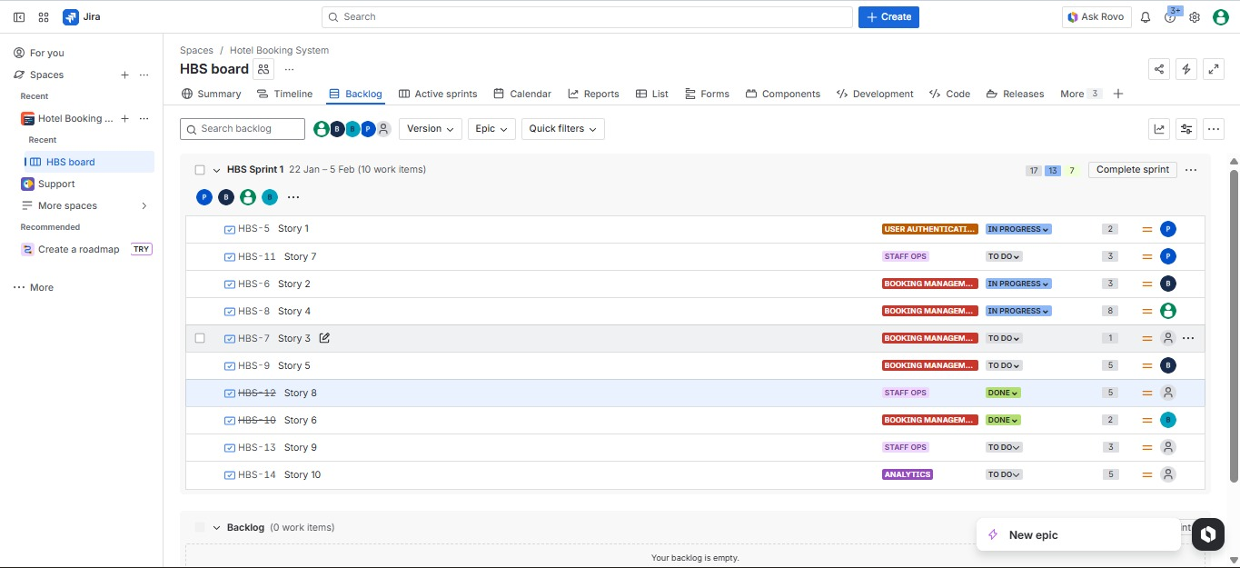
BACKLOG EXPLANATION
This screenshot displays the project Backlog, which serves as the central repository for all requirements. The work is organized into four major Epics: User Authentication, Booking Management, Staff Ops, and Analytics. These Epics group related user stories to ensure a structured development approach. The stories have been prioritized, estimated with story points, and assigned to the first Sprint.

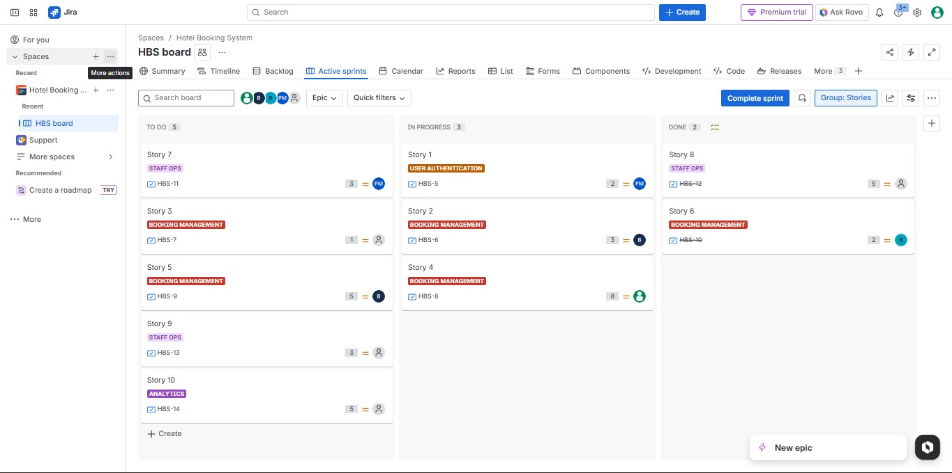
ACTIVE SPRINT VIEW
This view shows the currently active Sprint 1. We have selected high-priority user stories from the 'User Authentication' and 'Booking Management' epics for this initial 2-week iteration. The total story points selected align with the team's estimated capacity, ensuring a realistic workload.

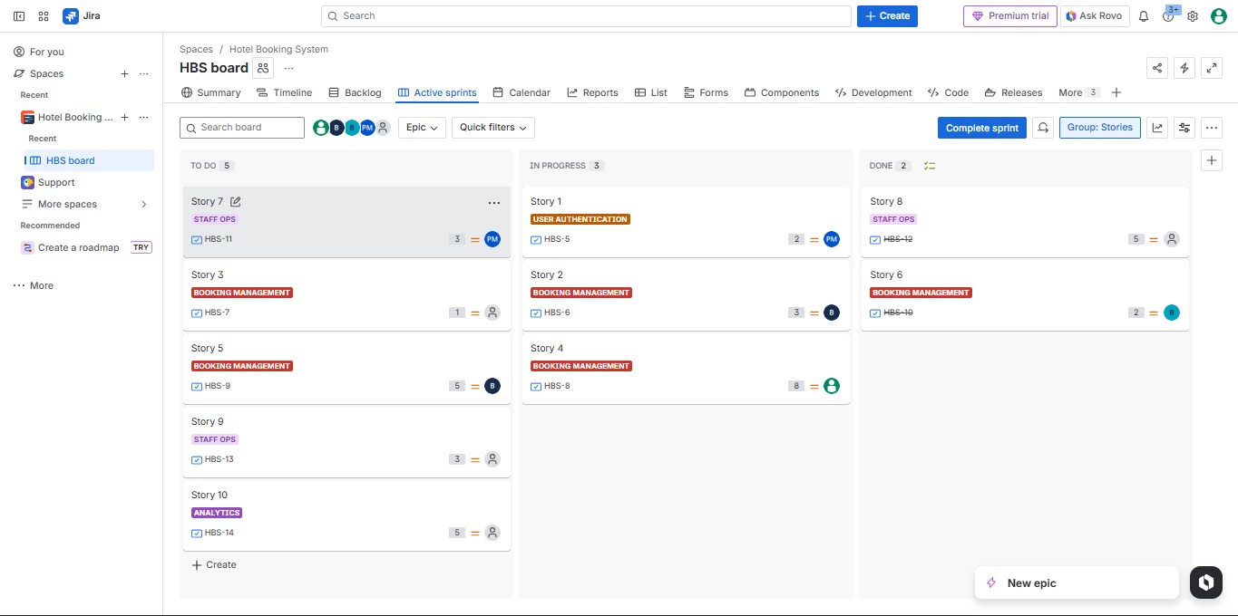
BOARD VIEW EXPLANATION
The Scrum Board visualizes the team's workflow using three standard columns: 'To Do', 'In Progress', and 'Done'. This provides instant visibility into project status. As team members begin working on a story, they move the card across the board, facilitating transparency and daily progress tracking

SPRINT DETAILS
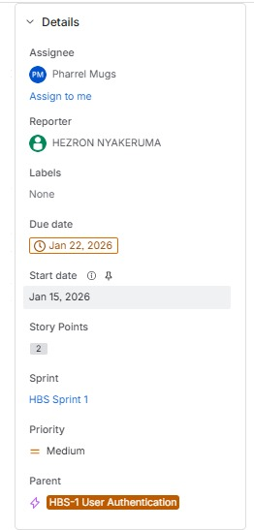
This detail view highlights the sprint planning parameters. Each user story has been assigned a complexity score using Fibonacci story points (e.g., 2, 3, 5, 8). Additionally, every task is assigned to a specific team member (indicated by the user avatar), ensuring clear ownership and accountability for every deliverable.

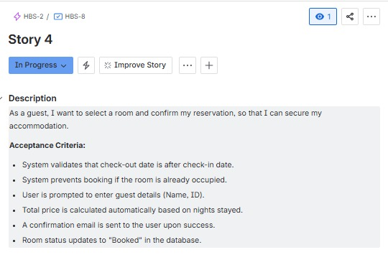
This screenshot demonstrates a fully detailed User Story: 'Online Room Booking'. It follows the standard 'As a... I want... So that...' format to define user value. Crucially, it includes specific Acceptance Criteria (e.g., system validation of dates, prevention of double-booking) which serve as the Definition of Done for testing and quality assurance.

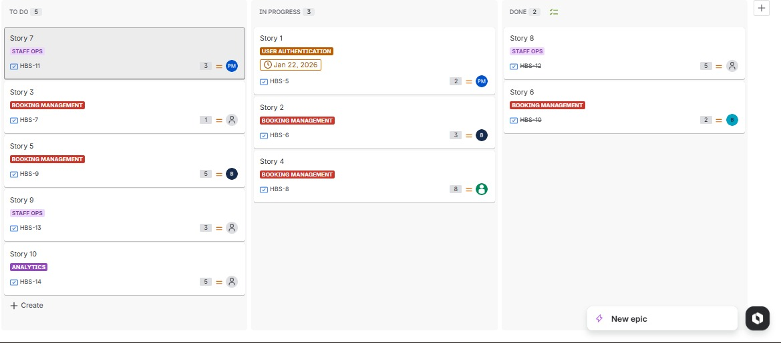
WORKFLOW TRANSITIONS
This image captures the workflow transition process. Jira allows for drag-and-drop movement of issues through the pipeline. Moving a story from 'To Do' to 'In Progress' automatically updates the status for all stakeholders, signaling that work has commenced on that specific feature

This screenshot demonstrates a fully detailed User Story: 'Online Room Booking'. It follows the standard 'As a... I want... So that...' format to define user value. Crucially, it includes specific Acceptance Criteria (e.g., system validation of dates, prevention of double-booking) which serve as the Definition of Done for testing and quality assurance

